Two types of compression:
Lossy/Lossless
Lossy loses data when computer is turned off
Loses quality when decompressed
2^bits = colours

Lossless – Compressed using bits to determine the colour, and how many of said colour, instead of using bits for each pixel.
Dictionary encoding – Creating an index of every frequently occurring value
Example: 1 12 3 = I hate you, with words being in an array I guess.

Combined encryption: Using your private key and your senders public key, useful so only the intended target can decrypt it.

Hashing functions: Turns a string into a key, using an algorithm
Seeds basically
Can`t reverse engineer to find the input value
Big o notation O(1) - constant

Additional used for hashing: Getting values quickly by going through a hash table

Cryptographic algorithm:
“Salt” is extra data given before a value is hashed to get more variety and guarantee uniqueness

Lossy: when minimizing storage space is the priority aka video
Lossless, when quality of file is prioritized aka image
Run length encoding: Turning AAABBBBCC into 3A4B2C, lossless
Dictionary based encoding: 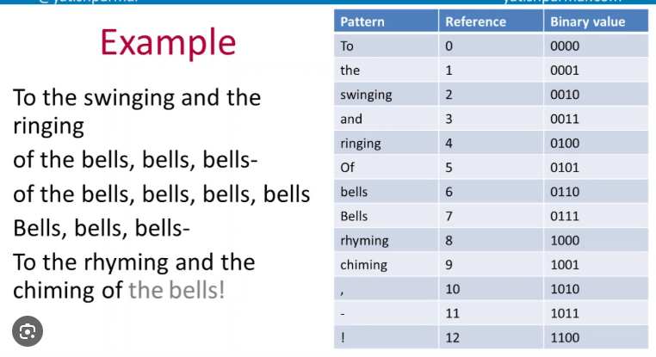
Symmetric encryption: Sharing the same private key for encryption and decryption between the sender and recipient
Asymmetric encryption: Using a pair of public and private keys, private keys known by the sender and public key known to the recipient

